# Functional Requirements:

What does the system need to do?

* Detect Intrusions
* Send notifications when detected
* Stream video
* Connect the hardware easily to the wifi and application

# Non-Functional Requirements:

* The application should load within 5 seconds
* The application and cloud structure should be able to log live streaming
* Back up system of storage if the cloud is not available (Don’t think this will be implemented due to time constraint)
* The hardware software set up should be a less than 10 minute job
* The hardware should be packaged for rugged waterproofness. Potential design input.
* Authenticate the user before entering application
* The UI/UX must be simple and intuitive. The live stream, and a current intrusion warning window

Performance, scalability, reliability, security, and other attributes

# Identify key Components and Modules

**Sensors:** IR sensor for picking up initial movement

**Microcontroller:** Central unit for processing data from sensors and controlling other components

**Cameras:** For visual monitoring and recording

**Communication modules:** Wi-Fi/Bluetooth for connectivity

**Power Supply:** Source of power for the entire system. It will initially be USB to POC but could consider battery too.

**Mobile Application:** Interface for user interaction and control

**Other:** Wi-Fi & Bluetooth, 2 buttons one for connectivity, 2 LED’s,

# Block Diagram:

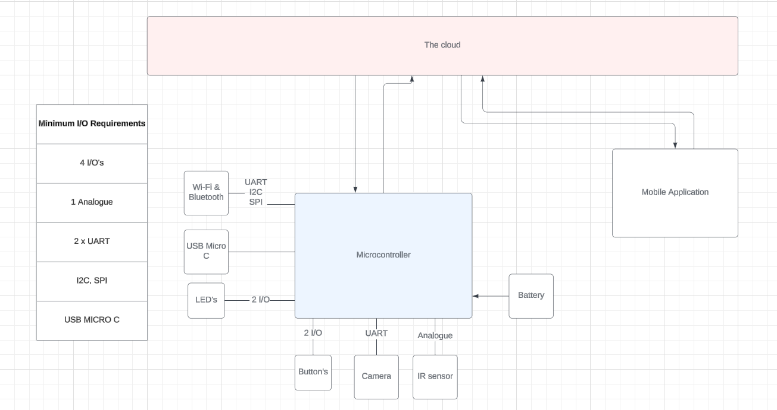

# Flowchart:

System Overview:

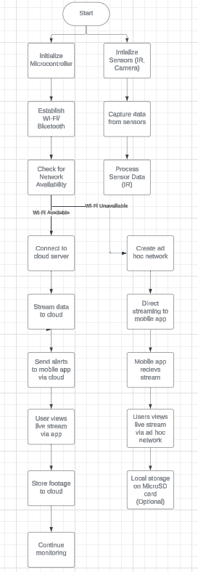

PIR sensor flowchart:

Camera Flowchart:

Communication flow chart:

Cloud Interaction:

Application flowchart:

# Environmental Considerations:

**Operating Conditions**: Temperature, humidity, outdoor/indoor use.

For a European market, we can consider between -10°C and 30°C

It will made for outdoor use, therefore should be water proof and able to keep a clean camera and PIR sensor in varying weather conditions

**Power Consumption**: Battery life, power management strategies.

I would expect the battery on a device like this to last for a few days, with a rechargeable options when advancing into production

**Physical Size and Weight**: Especially important for components like the drone.

The physical size 15widthx15length by 20heightcm

# Technical Feasibility:

**Connectivity:** Range will have to be 10m plus as the multiple sensors will be expected to be spread

**Processing power:**

|  |  |
| --- | --- |
| **Module Model** | **ESP32-CAM** |
| **Package** | **DIP-16** |
| **Size** | **27*40.5*4.5（±0.2）mm** |
| **SPI Flash** | **default 32Mbit** |
| **RAM** | **Internal 520KB + External 8MB PSRAM** |
| **Bluetooth** | **Bluetooth 4.2 BR/EDR and BLE standards** |
| **Wi-Fi** | **802.11 b/g/n/e/i** |
| **Support Interfaces** | **UART、SPI、I2C、PWM** |
| **Support TF Card** | **up to 4G** |
| **IO Pins** | **9** |
| **Serial Port Speed** | **default 115200 bps** |
| **Image Output Format** | **JPEG(only OV2640 support),BMP,GRAYSCALE** |
| **Spectrum range** | **2400 ~2483.5MHz** |
| **Antenna Type** | **On-board PCB antenna, gain 2dBi** |
| **Transmit Power** | **802.11b: 17±2 dBm (@11Mbps)** |
|  | **802.11g: 14±2 dBm (@54Mbps)** |
|  | **802.11n: 13±2 dBm (@MCS7)** |
| **Receive Sensitivity** | **CCK, 1 Mbps: -90dBm,** |
|  | **CCK, 11 Mbps: -85 dBm** |
|  | **6 Mbps (1/2 BPSK): -88 dBm** |
|  | **54 Mbps (3/4 64-QAM): -70dBm** |
|  | **MCS7 (65 Mbps, 72.2 Mbps): -67dBm** |
| **Power Consumption** | **Flash off: 180mA@5V,** |
|  | **Flash on and brightness to maximum: 310mA@5V** |
|  | **Deep-sleep: the lowest power consumption can reach 6mA@5V** |
|  | **Moderm-sleep: minimum 20mA@5V** |
|  | **Light-sleep: minimum 6.7mA@5V** |
| **Security** | **WPA/WPA2/WPA2-Enterprise/WPS** |
| **Power supply range** | **4.75-5.25V** |
| **Operating Temperature** | **-20 ℃ ~ 70 ℃** |
| **Storage Environment** | **-40 ℃ ~ 125 ℃ , < 90%RH** |

|  |  |  |
| --- | --- | --- |
| **Features** | **ESP32** | **STM32** |
| CPU clock speed | 240MHz per core | 168MHz |
| Number of cores | Dual-Core | Single-core |
| Available RAM | 520 KB SRAM (internal) | 192KB SRAM |
| Built in Wi-Fi/Bluetooth | 802.11 b/g/n Wi-Fi  Bluetooth 4.2 BR/EDR and BLE standards | No Wi-Fi and Bluetooth, to be added externally |

# Budget Estimate and parts list:

|  |  |  |
| --- | --- | --- |
| Parts | Link | Cost |
| ESP32-CAM module |  | $10 |
| ESP32-CAM-MB  Or  The FTDI  And the lead | https://www.amazon.com/Aideepen-ESP32-CAM-Bluetooth-ESP32-CAM-MB-Arduino/dp/B08P2578LV?th=1 | $14 |
| PIR sensor | https://www.mikrotronica.cc/pagina-del-producto/hc-sr501 | $3 |
| 3 buttons |  |  |
| 3 LED’s |  |  |
| USB 2.0 Cable Type A/B | For Arduino |  |
| How do I power the ESP32 |  |  |
| Resistors for LEDS?? |  |  |
| Lithium battery power pack | https://www.amazon.com/2600mAh-Lithium-19-24Wh-Rechange-Connectors/dp/B08NR4D4K5 | Ask them question on which one I need for this |
|  |  |  |
|  |  |  |
|  |  |  |

For power requirements

<https://arduino.stackexchange.com/questions/77844/powering-an-esp32cam-by-a-battery>